**Triangles**

# What are congruent figures?

* + Two figures are said to be **congruent**, if they are of the same shape and of the same size.
  + Two circles of the same radii are congruent.
  + Two squares of the same sides are congruent.

# Congruent triangles

If two triangles ABC and DEF are congruent under the correspondence A ↔ D*,* B *↔* E and C *↔* F, then symbolically, it is expressed as Δ ABC  Δ DEF.

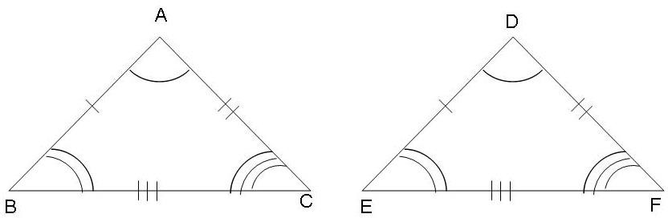

In congruent triangles, **corresponding parts are equal**. We write in short ‘*CPCT*’ for corresponding parts of congruent triangles.

# SAS (Side – Angle – Side) congruence rule

Two triangles are congruent if two sides and the included angle of one triangle are equal to the two sides and the included angle of the other triangle.

**Note**: SAS congruence rule holds but not ASS or SSA rule.

# ASA (Angle – Side – Angle) congruence rule

Two triangles are congruent if two angles and the included side of one triangle are equal to two angles and the included side of other triangle.

# AAS (Angle – Angle – Side) congruence rule

Two triangles are congruent if any two pairs of angles and one pair of corresponding sides are equal.

# SSS (Side – Side – Side) congruent rule

If three sides of one triangle are equal to the three sides of another triangle, then the two triangles are congruent.

# RHS (Right Angle – Hypotenuse – Side) congruence rule

If in two right triangles the hypotenuse and one side of one triangle are equal to the hypotenuse and one side of the other triangle, then the two triangles are congruent.

# Isosceles triangle and its properties

* + A triangle in which two sides are equal is called an **isosceles** triangle.
  + Angles opposite to equal sides of an isosceles triangle are equal.
  + The sides opposite to equal angles of a triangle are equal.

# Inequalities in a triangle

* + If two sides of a triangle are unequal, the **angle opposite to the longer side is greater**.
  + In any triangle, the **side opposite to greater (larger) angle is longer**.
  + The **sum of any two sides** of a triangle is **greater than the third side**.
  + The **difference between any two sides** of a triangle is **less than the third side**.